**Meteorite Metrics Tableau Analysis of Impact Data**

**Problem Statement:**

ABC Company, a leading provider of aerospace technology solutions, faces the challenge of effectively analyzing meteorite impact data to enhance space mission planning and spacecraft design. Despite the abundance of available data on meteorite landings, ABC Company struggles to extract meaningful insights and translate them into actionable strategies. The lack of a structured approach to analysing meteorite impact data hampers ABC Company's ability to accurately assess the risks posed by meteorite impacts to space assets and infrastructure. Consequently, there is an urgent need for ABC Company to develop robust methodologies and tools for processing and interpreting meteorite impact data, enabling informed decision-making and proactive risk mitigation measures in its aerospace endeavours.

**Prerequisites:**

* Basic understanding of Data Analytics

[What Is Data Analytics? - An Introduction (Full Guide)](https://youtu.be/yZvFH7B6gKI?si=jD37tQzKJH1vl56A)

* Awareness of the lifecycle of a Data Analytics Project

[A Beginners Guide To The Data Analysis Process](https://youtu.be/lgCNTuLBMK4?si=a_J79oNSQIGNuNlH)

* Understand Tableau Interface- [Link](https://www.youtube.com/watch?v=oIw8xJ1Fy3w)
* Download Tableau Desktop-[Link](https://www.tableau.com/products/desktop/download)

**Objective:**

An objective is a specific, measurable, and time-bound goal or target that an individual or organization aims to achieve. Objectives are typically set to guide actions and decision-making towards desired outcomes. They are often a part of broader goals and help to clarify what needs to be accomplished within a certain timeframe. Objectives should be realistic, achievable, and relevant to the overall mission or purpose, providing a clear direction for efforts and resources.

**Task:**

* Employ Tableau visualizations to analyse meteorite landing data, focusing on key metrics such as the count of meteorite landings, recorded lengths, and total masses, to gain insights into the frequency and characteristics of meteorite impacts globally.
* Utilize Tableau dashboards to explore the distribution of meteorite masses by country and visualize the geographic locations of metropolitan areas with the highest counts of meteorite landings, aiming to identify patterns and trends in meteorite impacts for informed decision-making and risk assessment in aerospace endeavours.

**Dataset**: [Link](https://www.kaggle.com/datasets/sahirmaharajj/meteorite-landings-analysis)

**Solution Development Procedure:**

* In Tableau, the "Connect" option refers to the initial step in the data visualization process where users connect to various data sources to import data into Tableau for analysis and visualization.

* When you select the "Connect" option in Tableau, you are presented with a variety of data connection options.



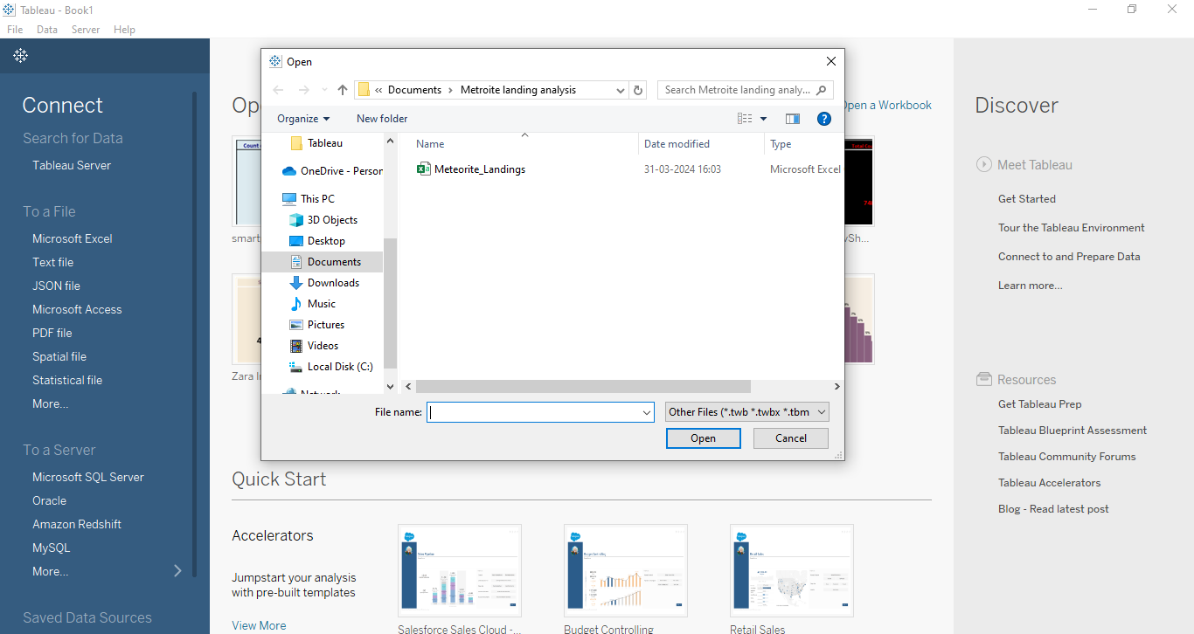

* Once we load the data into the Tableau.

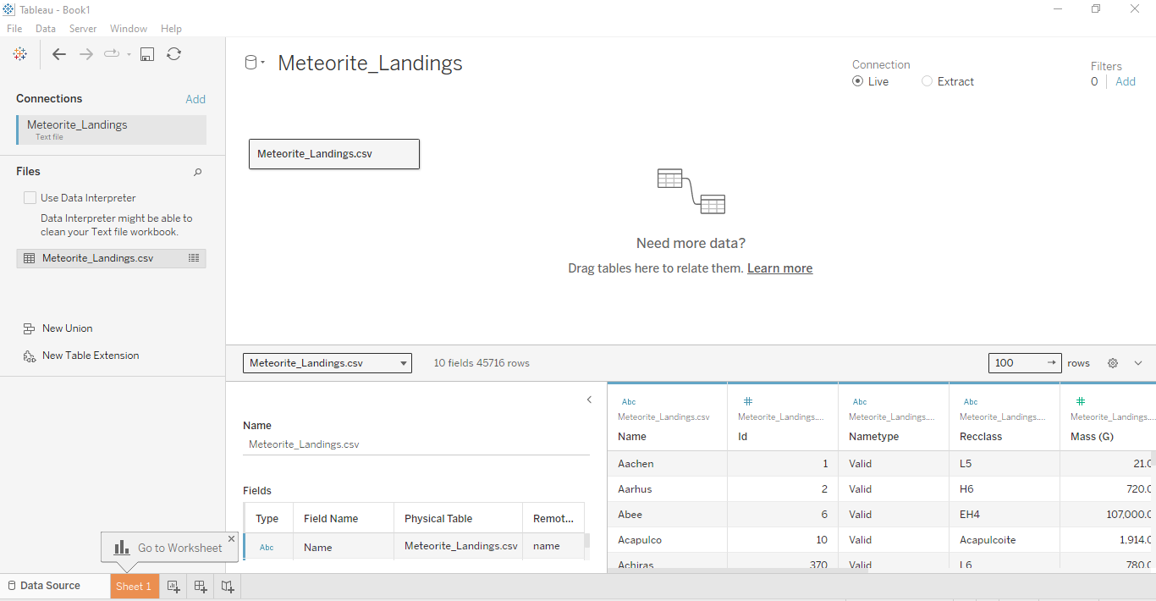

* Now , we proceed to create dashboard for Meteorite Metrics : Impact Analysis
* To create the dashboard, which will satisfy the task above, we consider the followingcolumns:
  + Count of Meteorite Landings
  + Recorded Lengths of Meteorites
  + Total Masses of Meteorites
  + Total Masses of Meteorites by Countries
  + Count of Metropolitan Landings by Geo Location.
* We have created the dashboard which is presented below.

**Dashboard:**

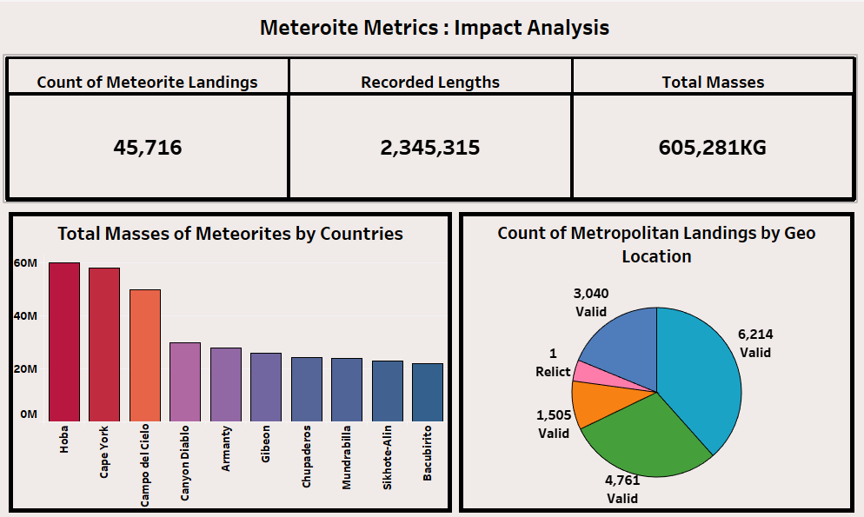

**Explanation Video:** Link

Note: The explanation video for the dashboard is in the link above.

**Insights:**

Insights refer to valuable and meaningful understandings or perceptions gained from analysing data, information, or experiences. They provide deeper understanding, clarity, or revelation regarding a particular subject or situation.

* The data reveals a significant number of recorded meteorite landings, totalling 45,716, indicating the frequency of meteorite impacts on Earth's surface. This highlights the importance of understanding and studying these celestial events to assess their potential impact on human activities and the environment.
* The total mass of meteorites, amounting to 605,281 kilograms, underscores the substantial material deposited by meteorite impacts. Notably, locations such as Hobo, Campo del Cielo, and Chelyabinsk exhibit considerable meteorite masses, indicating the concentration of impact events in these areas. Understanding the distribution of meteorite masses by country provides valuable insights into the geological and atmospheric processes driving meteorite impacts.
* The analysis of metropolitan landings categorizes meteorite impacts based on their geographic locations and classification status. The predominance of valid metropolitan landings in specific locations suggests varying degrees of meteorite activity across different regions. By identifying patterns in metropolitan landings, researchers and policymakers can better assess the risk posed by meteorite impacts and implement appropriate mitigation strategies to protect vulnerable populations and infrastructure.

**Conclusions :**

Conclusions are logical deductions or decisions drawn from observations, evidence, or analysis. Conclusions are often based on the findings or results of a study, experiment, or evaluation, and they aim to summarize key insights or outcomes. Effective conclusions should be supported by evidence, logical reasoning, and critical thinking, leading to well-informed decisions or actions.

* The comprehensive analysis of meteorite landing statistics underscores the significance of understanding meteorite impacts on Earth's surface. These insights contribute to our knowledge of celestial events and aid in assessing potential risks and impacts on human activities and infrastructure.
* By visualizing the distribution of meteorite masses by country and identifying key impact locations such as Hobo, Campo del Cielo, and Chelyabinsk, this analysis provides valuable information for researchers, policymakers, and stakeholders involved in space exploration, aerospace technology, and planetary defence initiatives.
* The examination of metropolitan landings highlights the varied nature of meteorite impacts and their classification status, enabling a better understanding of regional differences in meteorite activity. This knowledge can inform risk assessment and mitigation efforts, helping to protect urban populations and critical infrastructure from potential meteorite impacts in the future.